- Lobarotoriya
Mavzu:Formani JavaScript orqali tekshirish (validation)
Fan nomi:Web texnologiya.
Ishdan maqsad:Ushbu amaliy ishning asosiy maqsadi — foydalanuvchi tomonidan kiritilgan ma'lumotlarni serverga yuborishdan oldin brauzerning o'zida tahlil qilish, xatolarni aniqlash va foydalanuvchiga to'g'ri ko'rsatmalar berish tizimini yaratishni o'rganishdir.

Nazariy ma’lumot:1.

Validatsiyaning ikki turi
Veb-dasturlashda validatsiya odatda ikki bosqichda amalga oshiriladi:
Client-side (Mijoz tomoni): JavaScript yordamida brauzerda tekshiriladi. Bu foydalanuvchiga tezkor javob qaytarish uchun kerak.
Server-side (Server tomoni): Ma'lumotlar bazasiga yozishdan oldin serverda tekshiriladi. Bu xavfsizlik uchun majburiydir.

2. JavaScript validatsiyasining asosiy usullari

A) Majburiy maydonlarni tekshirish (Required Fields)
Elementning .value xossasi bo‘sh yoki yo‘qligini tekshirish orqali amalga oshiriladi.
JavaScript
if (input.value.trim() === "") {
// Xatolik xabari
}

B) Regulyar ifodalar (Regular Expressions - RegExp)
Bu murakkab formatlarni (email, telefon, parollar) tekshirishning eng kuchli usulidir.

C) Ma'lumot uzunligini tekshirish
Parollar yoki foydalanuvchi nomlari uchun minimal va maksimal uzunlik chegaralarini o‘rnatish:
JavaScript
if (password.value.length < 8) {
alert("Parol kamida 8 ta belgidan iborat bo'lishi kerak!");
}

3. Validatsiya jarayonining bosqichlari
Eventni tutish: Formaning submit hodisasini tinglash.
Standart harakatni to'xtatish: event.preventDefault() yordamida sahifa yangilanib ketishining oldini olish.
Tekshirish (Logic): if-else yoki switch operatorlari orqali har bir inputni shartlarga solish.
Visual Feedback: Agar xato bo'lsa, input atrofiga qizil rang berish yoki xabar chiqarish. Agar xato bo'lmasa, ma'lumotni yuborish.

4. Constraint Validation API
Zamonaviy brauzerlarda JavaScript'ning tayyor metodlari ham mavjud:
checkValidity(): Element shartlarga javob berishini tekshiradi.
setCustomValidity(): Maxsus xatolik xabarini o'rnatadi.
validity.valid: Elementning holati to'g'ri yoki noto'g'riligini qaytaruvchi boolean qiymat.
Kod qismi:/* passport.css - animations and transitions for passport page */
/* ANIM: sections below are labeled with ANIM comments to help you find and tweak animations quickly. */
:root{
/* HIGH-CONTRAST palette to make changes immediately visible */
--bg: #06121a; /* very dark navy background */
--card-start: #ffd166; /* warm gold start */
--card-end: #ff9f1c; /* orange end */
--accent: #0be5a8; /* bright teal accent for values */
--label: #f7f7f7; /* near-white labels */
--muted: rgba(255,255,255,0.85);
}
html,body{height:100%;}
body{
font-family: 'Segoe UI', Tahoma, Geneva, Verdana, sans-serif;
background: linear-gradient(180deg,var(--bg) 0%, #042026 100%);
display:flex;
align-items:center;
justify-content:center;
margin:0;
padding:20px;
}

.passport-card{
/* ANIM: card entrance - transform + opacity transition (see .passport-card.card--show) */
width:520px;
max-width:95%;
background: linear-gradient(135deg, var(--card-start) 0%, var(--card-end) 100%);
border-radius:18px;
padding:28px 30px;
color: #f3f7f8;
position:relative;
overflow:hidden;
border:1px solid rgba(255,255,255,0.06);
box-shadow: 0 20px 50px rgba(2,6,23,0.6);
transform: translateY(30px) scale(.98);
opacity:0;
transition: transform 560ms cubic-bezier(.2,.9,.2,1), opacity 420ms ease;
}
.passport-card.card--show{
transform: translateY(0) scale(1);
opacity:1;
}

.watermark{
/* ANIM: watermark rotation / subtle motion (keyframes: watermark-rotate) */
position:absolute;
right:-40px;
bottom:-40px;
opacity:0.06;
font-size:170px;
font-weight:800;
color:#fff;
pointer-events:none;
transform: rotate(-12deg);
animation: watermark-rotate 16s linear infinite;
}
@keyframes watermark-rotate{
from{transform: rotate(-12deg) scale(.98)}
50%{transform: rotate(-8deg) scale(1.02)}
to{transform: rotate(-12deg) scale(.98)}
}

h2{
text-align:center;
text-transform:uppercase;
letter-spacing:2px;
margin:0 0 18px 0;
color: rgba(255,255,255,0.95);
border-bottom:1px solid rgba(255,255,255,0.06);
padding-bottom:12px;
}

/* ANIM: staggered info reveal - elements get class 'show' via JS and use the slideUp keyframes */
.info-group{
display:flex;
justify-content:space-between;
align-items:center;
margin-bottom:12px;
opacity:0;
transform: translateY(8px);
}
.info-group.show{
animation: slideUp 420ms cubic-bezier(.15,.9,.25,1) forwards;
animation-delay: var(--delay, 0ms);
}
@keyframes slideUp{
from{opacity:0; transform: translateY(8px)}
to{opacity:1; transform: translateY(0)}
}

.label{
font-size:0.78rem;
color:var(--label);
text-transform:uppercase;
}
.value{
font-size:1.05rem;
font-weight:700;
color:var(--accent);
letter-spacing:0.3px;
}

.serial-number{
/* ANIM: serial number glow - keyframes: serial-glow */
font-family: 'Courier New', Courier, monospace;
background: rgba(0,0,0,0.12);
padding:6px 12px;
border-radius:6px;
color:#f6d55c;
box-shadow: 0 6px 18px rgba(0,0,0,0.18) inset;
position:relative;
overflow:hidden;
animation: serial-glow 2.6s ease-in-out infinite;
}
@keyframes serial-glow{
0%,100%{filter:brightness(1)}
50%{filter:brightness(1.25)}
}

.btn-verify{
/* ANIM: button ripple + temporary 'verified' visual. Ripple element inserted by JS as a child .ripple */
display:block;
width:100%;
padding:12px;
margin-top:18px;
background: rgba(10,15,10,0.18);
color: #f7f7de;
border:none;
border-radius:10px;
cursor:pointer;
font-weight:700;
position:relative;
overflow:hidden;
transition: background 260ms ease, transform 160ms ease;
}
.btn-verify:hover{ transform: translateY(-3px); background: rgba(10,15,10,0.26); }

/* ripple element created by JS */
.btn-verify .ripple{
position:absolute;
border-radius:50%;
transform: scale(0);
background: rgba(255,255,255,0.24);
animation: ripple 650ms ease-out;
pointer-events:none;
}
@keyframes ripple{
to{ transform: scale(6); opacity:0; }
}

/* small verified state */
.btn-verify.verified{
background: linear-gradient(90deg,#38b000,#2ecc71);
color:#04200f;
}

/* controls / add-field inputs */
#add-field-row input{
background: rgba(255,255,255,0.06);
color: #fff;
outline: none;
}

.info-group .remove-btn{
margin-left:12px;
background: rgba(200,30,30,0.9);
border: none;
color: #fff;
padding:4px 8px;
border-radius:6px;
cursor:pointer;
font-size:0.85rem;
display:none; /* shown only in edit mode */
}
.info-group.editing .remove-btn{ display:inline-block; }

/* Validation styles */
.invalid{
outline: 2px solid rgba(255,107,107,0.9);
background: rgba(255,107,107,0.03);
border-radius: 4px;
}
.error-message{
display:block;
color: #ffb3b3;
font-size: 0.78rem;
margin-top:6px;
}

.back-link{
display:block;
margin-top:12px;
text-align:center;
color: rgba(255,255,255,0.92);
text-decoration:none;
}
.back-link:hover{ text-decoration:underline }

/* responsive */
@media (max-width:540px){
.passport-card{ padding:18px; }
.watermark{ font-size:120px; right:-24px; bottom:-24px }
}

JavaScript (script.js):
document.getElementById("passportForm").addEventListener("submit", function(event) {
event.preventDefault(); // forma avtomatik yuborilishini to'xtatish
let isValid = true;

const fullname = document.getElementById("fullname").value.trim();
if(fullname === "" || !/^[A-Za-z\s]+$/.test(fullname)) {
document.getElementById("fullnameError").innerText = "Iltimos, to'g'ri F.I.O kiriting";
isValid = false;
} else {
document.getElementById("fullnameError").innerText = "";
}

const passportNumber = document.getElementById("passportNumber").value.trim().toUpperCase();
if(!/^[A-Z]{2}[0-9]{7}$/.test(passportNumber)) {
document.getElementById("passportError").innerText = "Iltimos, to'g'ri pasport raqamini kiriting (AA1234567)";
isValid = false;
} else {
document.getElementById("passportError").innerText = "";
}

const birthDate = new Date(document.getElementById("birthDate").value);
const today = new Date();
if(birthDate >= today) {
document.getElementById("birthError").innerText = "Tug‘ilgan sanani to'g'ri kiriting";
isValid = false;
} else {
document.getElementById("birthError").innerText = "";
}

const expiryDate = new Date(document.getElementById("expiryDate").value);
if(expiryDate <= today) {
document.getElementById("expiryError").innerText = "Amal qilish muddati bugundan keyingi bo'lishi kerak";
isValid = false;
} else {
document.getElementById("expiryError").innerText = "";
}

const gender = document.getElementById("gender").value;
if(gender === "") {
document.getElementById("genderError").innerText = "Iltimos, jinsingizni tanlang";
isValid = false;
} else {
document.getElementById("genderError").innerText = "";
}

if(isValid) {
const passportData = {
fullname: fullname,
passportNumber: passportNumber,
birthDate: document.getElementById("birthDate").value,
expiryDate: document.getElementById("expiryDate").value,
gender: gender
};
document.getElementById("formSuccess").innerText = "Formangiz muvaffaqiyatli yuborildi!";
document.getElementById("jsonOutput").innerText = JSON.stringify(passportData, null, 4);
console.log("JSON ma'lumot:", passportData);
} else {
document.getElementById("formSuccess").innerText = "";
document.getElementById("jsonOutput").innerText = "{}";
}
});

Amaliy qismi:
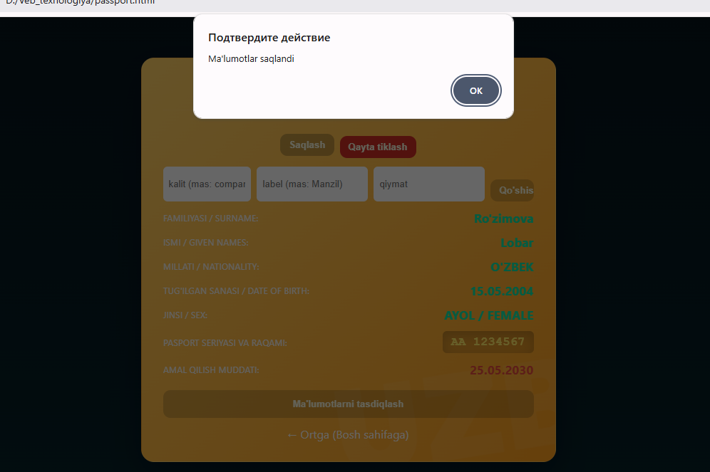

- rasim: malumotlarni tahrirlagan qismi.
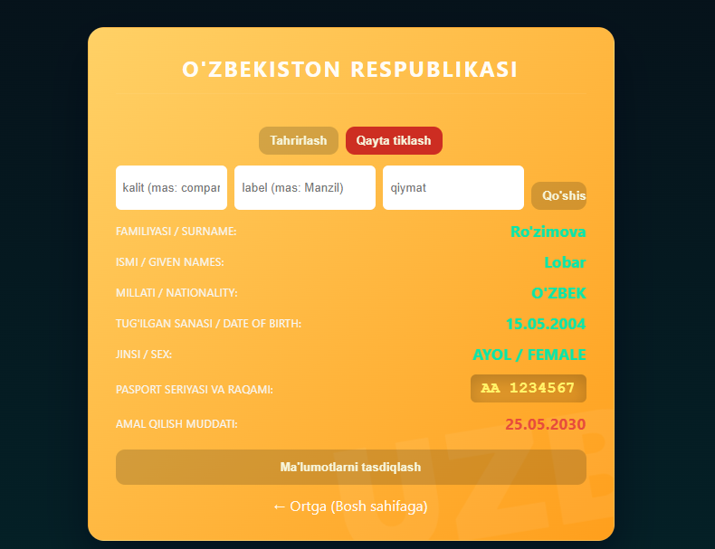
2-rasim.Sahifamning tayyor qismi:
Xulosa:
Umumiy xulosa qilib aytganda, formani JavaScript orqali tekshirish — bu veb-dasturlashning ajralmas qismi bo‘lib, u loyihaning professionalligi, xavfsizligi va foydalanuvchilar uchun qanchalik interaktiv ekanligini belgilab beruvchi asosiy mezonlardan biridir.

